**ESS 132 Week 7/8 Tasks – Calculations related to groundwater**

1. **Ocean-groundwater interactions**

A restaurant was built 400 m away from the shoreline. The water needs of the restaurant are supplied by a groundwater well on the property. From the information provided on the figure below, answer the following questions. (Diagram not to scale.)

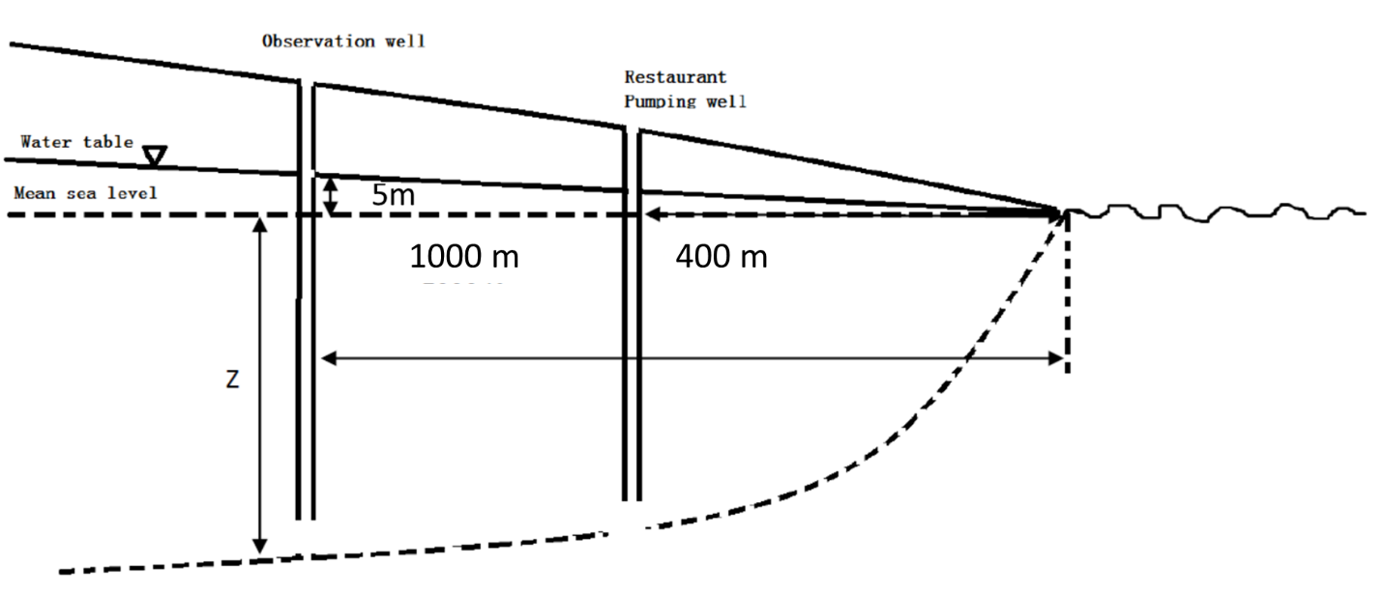

1. What is the depth below sea level of the freshwater/seawater interface in the observation well 1000m away from the coastline?

z = 40h = 40*5m = 200 m

1. How deep could the restaurant’s well be (with respect to sea level) before it reaches the freshwater/seawater interface? (Assume a linear drop in water table from inland to the coast.)

(5 m/1000 m) = (h/400 m)

h = 400 m * 5 m/1000 m = 2 m

z = 40h = 40*2 m = 80 m

The well should be less than 80 m deep. I would not drill the well all the way down to 80 m, as doing so will lower the water table, which can potentially cause me to draw up seawater.

1. **Cones of depression and “drawdown” of the water table due to groundwater extraction**

An unconfined aquifer is composed of medium sand and the thickness of the saturated part of the aquifer is 100 m. The pumping rate is 800 liters per minute. The drawdown (decrease in water table height) in an observation well 75 m away is 10 m, and the drawdown in a second observation well 500 m away is 0.8 m. The drawdown at the pumping well is 45m. You will need to use the following equation which approximates the relationships between pumping rate, drawdown and Ksat:

S = Q * ln (r2/r1)

2πKsatH0(h2-h1)

Where S = drawdown (H0 – H) (m)

H0 = original height of water table at well (m)

H = current height of water table at well (m)

h1 = height of water table at the least distant observation well at a distance of r1 (m)

h2 = height of water table at the most distant observation well at a distance of r2 (m)

Q = pumping rate (liters per day)

Ksat = saturated hydraulic conductivity per m2 (also known as transmissivity)

1. Use a piece of paper to make a sketch of a cross-section through the well and aquifer to show the cone of depression and illustrate all of the information in the question above. (It doesn’t need to be to scale!)
2. Find the saturated hydraulic conductivity (Ksat) of the aquifer in liters per day per m2.
3. How do you think a much lower Ksat would affect the shape of the cone of depression?

It would produce a narrower and deeper cone of depression as it is now more difficult for groundwater to move horizontally to refill the cone of depression.